**CHATBOT DEPLOYMENT USING IBM CLOUD WATSON ASSISTANT INNOVATION:**

**OVERVIEW:**

Over the last few years, chatbots have become more widely available and more popular as a customer service solution. Chatbot deployment involves the process of implementing and launching a chatbot into a live environment to interact with users. They can be deployed on various platforms, such as websites, mobile apps, messaging platforms, or voice assistants, and assist users by answering questions, providing information, guiding through processes, or even performing tasks like making reservations or placing orders.

Our project is a solution that is customized for specific requirements for marketing agencies. The marketing agencies are facing a lot of challenges, including lead generation,client communication, and finally reporting. Our project helps to overcome all these challenges by enhancing client interactions and improving overall agency efficiency. It also enhances client communication by providing real-time updates on project progress and addressing common queries. The main objective is to give a better experience with defined personas with the name, tone, and style of the chatbot. It is informative, can give endless service to the users, and can have friendly conversations with them.

**SOLUTION:**

Chatbot deployment using IBM Cloud Watson Assistant involves several steps. First, the chatbot is designed and built using the IBM Cloud Watson Assistant platform. This includes defining intents, creating dialog flows, and training the chatbot using sample user inputs. Once the chatbot is developed, it is integrated into any desired channels, such as websites, mobile apps, or messaging platforms. Watson Assistant provides easy integration options and supports various communication channels. After integration, the chatbot is thoroughly tested to ensure its functionality and accuracy. This involves testing different user scenarios, evaluating the chatbot's responses, and making necessary adjustments to improve its performance. Once the testing is complete, the chatbot is deployed to the live environment. Watson Assistant offers deployment options that allow you to scale and manage the chatbot effectively. After deployment, continuous monitoring and maintenance are crucial. Watson Assistant provides analytics and insights to track user interactions, identify areas for improvement, and enhance the chatbot's performance over time. In summary, chatbot deployment using IBM Cloud Watson Assistant involves designing, building, integrating, testing, deploying, and monitoring the chatbot to provide effective and efficient conversational experiences for users.

**WORKFLOW OF CHATBOT AT THE BACKEND:**

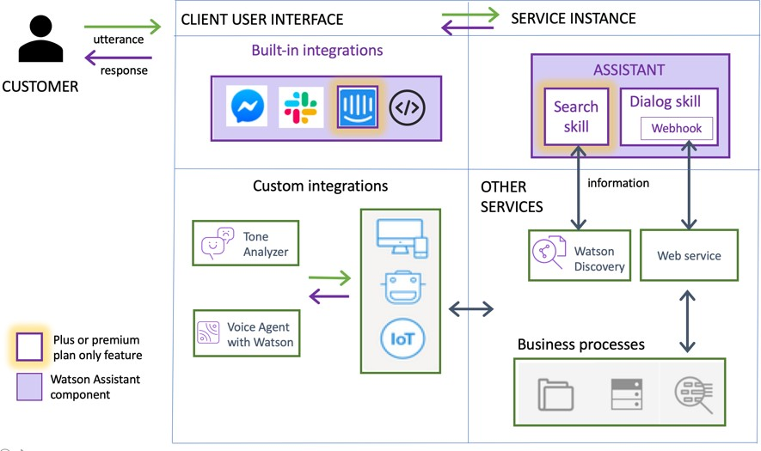

**PROCESS:**

**Steps to be followed to deploy a chatbot :**

**INTENTS**

**CONDITIONS DIALOG SKILL**

**ENTITIES**

**Intents:** Intent in the context of a chatbot refers to the user's purpose or goal when they interact with the chatbot**.**

**Entities:** Entities in a chatbot refer to specific pieces of information or data that the bot needs to extract from the user's input in order to understand and respond accurately.

**Step 1:** Go t**o** IBM **cloud’s** login page and create an account to access the the resources that is present in it.

**Step2:** Next click on the **catalog** menu which is present on the left most corner of the web page.

**Step 3:** Click and move forward to **Watson assistant** tab.

**Step 4:** Move on to **Resource list** menu and slide towards to **Services** menu item to access other services from IBM Watson assistant.

**Step 5:** Press **launch Watson assistant** button which will be displayed in blue.From step 5 actual deployment of chatbot takesplace.

**Step 6:** Name your Watson assistant with your service.

Ex: Marketing agency service assistance.

**Step 7: Enable preview link** to use that to deploy it in the targeted or intended website.

**Step 8:** Finally click **create assistant** button.Now the skeleton of chatbot is created.

**Step 9:** Go to **add catalog skill** tab to create entities and intents.

**Step 10:** By clicking on the **create skill** tab a page will be displayed,which contains the name of created IBM Watson assistant.

**Step 11:** Go to the page was viewed in step 10 and add the intents and entities by giving the message templates for the intended websites .

Ex: #greetings-intent

Hello,hi,welcome,thankyou……. - entities

**FEATURES:**

Chatbot deployment using Watson Assistant offers several key features that enhance the conversational experience and streamline the deployment process. Here are some notable features:

**Natural Language Processing (NLP):** Watson Assistant leverages advanced NLP capabilities to understand and interpret user inputs, allowing the chatbot to provide accurate and contextually relevant responses.

**Dialog Flow Management:** With Watson Assistant, you can easily design and manage complex dialog flows. This feature enables you to create dynamic conversations, handle user intents, and guide users through multi-turn interactions.

**Integration Options:** Watson Assistant provides seamless integration with various channels, including websites, mobile apps, messaging platforms, and voice assistants. This flexibility allows you to deploy your chatbot across multiple platforms and reach a wider audience.

**Contextual Understanding:** The chatbot can maintain context throughout a conversation, remembering previous user inputs and using that information to provide more personalized and relevant responses. This feature enhances the user experience and makes interactions more natural.

**Multi-language Support:** Watson Assistant supports multiple languages, enabling you to deploy chatbots that can communicate with users in their preferred language. This feature is particularly useful for global deployments or multilingual user bases.

**Analytics and Insights:** Watson Assistant provides analytics and reporting capabilities to track user interactions, measure performance metrics, and gain insights into user behavior. This data helps you optimize the chatbot's performance and identify areas for improvement.

**Continuous Learning:** Watson Assistant allows you to continuously train and improve your chatbot by analyzing user interactions and incorporating user feedback. This iterative learning process helps the chatbot evolve and deliver better responses over time.

These features make Watson Assistant a powerful tool for chatbot deployment, enabling you to create intelligent and engaging conversational experiences for your users.

**APPLICATIONS:**

Chatbot deployment using IBM Cloud Watson Assistant can be applied in various industries and use cases. Here are some common applications:

**Customer Support:** Chatbots can handle customer inquiries, provide product information, troubleshoot common issues, and offer personalized recommendations. They can assist customers 24/7, reducing the need for human intervention and improving customer satisfaction.

**E-commerce:** Chatbots can help users navigate through product catalogs, provide recommendations based on user preferences, assist with order tracking, and answer frequently asked questions about shipping, returns, and payments.

**Banking and Finance:** Chatbots can handle basic banking tasks such as checking account balances, transferring funds, and providing information about banking services. They can also assist with financial planning, investment advice, and fraud detection.

**Travel and Hospitality:** Chatbots can assist with travel bookings, provide information about flights, hotels, and local attractions, offer personalized recommendations based on user preferences, and handle customer inquiries about reservations or cancellations.

**Healthcare:** Chatbots can provide basic medical information, answer health-related questions, schedule appointments, remind patients about medication, and offer guidance on common symptoms or conditions. They can also help triage patients by assessing their symptoms and suggesting appropriate actions.

**Human Resources:** Chatbots can assist employees with HR-related queries, such as leave requests, benefits information, policy inquiries, and onboarding processes. They can provide quick and accurate responses, freeing up HR personnel for more complex tasks.

These are just a few examples, and the applications for chatbot deployment using IBM Cloud Watson Assistant can be customized to suit specific industry needs and use cases.

**BENEFITS:**

There are several benefits to deploying a chatbot using IBM Cloud Watson Assistant.

**Natural Language Processing (NLP):** Watson Assistant utilizes advanced NLP capabilities to understand and interpret user inputs accurately. This enables the chatbot to comprehend and respond to user queries in a more human-like manner.

**Easy Integration:** Watson Assistant offers seamless integration with various communication channels, including websites, mobile apps, messaging platforms, and voice assistants. This allows you to deploy the chatbot across multiple platforms and reach a wider audience.

**Scalability:** IBM Cloud provides a scalable infrastructure, allowing your chatbot to handle a large volume of user interactions without compromising performance. You can easily scale up or down based on your needs, ensuring a smooth user experience even during peak times.

**Multi-language Support:** Watson Assistant supports multiple languages, enabling you to cater to a global audience. This is particularly beneficial for businesses operating in multilingual environments or targeting international markets.

**Analytics and Insights:** IBM Cloud Watson Assistant provides analytics and insights into user interactions, allowing you to gain valuable insights into user behavior, preferences, and trends. This data can be used to optimize the chatbot's performance, improve user satisfaction, and make informed business decisions.

**Continuous Learning:** Watson Assistant allows you to continuously train and improve your chatbot by providing feedback and making updates to its knowledge base. This ensures that the chatbot stays up-to-date with the latest information and can adapt to changing user needs.

Overall, deploying a chatbot using IBM Cloud Watson Assistant offers benefits such as enhanced NLP capabilities, easy integration, scalability, multi-language support, analytics, and continuous learning, enabling you to deliver a more personalized and efficient conversational experience for your users.

**CONCLUSION:**

In conclusion, deploying a chatbot using IBM Cloud Watson Assistant offers a comprehensive and efficient solution for creating conversational experiences. With Watson Assistant, you can design and build your chatbot using intuitive tools and features, such as defining intents and dialog flows. The integration capabilities of Watson Assistant allow you to seamlessly deploy your chatbot across various channels, including websites, mobile apps, and messaging platforms. This ensures that your chatbot can reach and assist users wherever they are. The testing phase is crucial to ensure the functionality and accuracy of the chatbot. Watson Assistant provides robust testing capabilities, allowing you to evaluate different user scenarios and fine-tune the chatbot's responses for optimal performance. Once the chatbot is ready, deploying it to the live environment is straightforward with IBM Cloud Watson Assistant. The platform offers scalable deployment options, enabling you to handle increasing user demands and manage your chatbot effectively. Continuous monitoring and maintenance are essential to ensure the chatbot's ongoing performance and user satisfaction. Watson Assistant provides analytics and insights to track user interactions, identify areas for improvement, and make necessary adjustments to enhance the chatbot over time. Overall, deploying a chatbot using IBM Cloud Watson Assistant empowers businesses to create intelligent and effective conversational experiences, improving customer engagement and satisfaction.